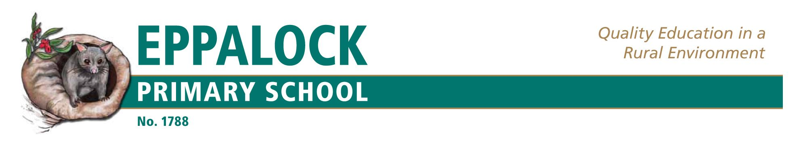
School Philosophy Policy
Statement of philosophy which includes Government School’s vision, mission, values and objectives.

Our school’s vision is to prepare young people to become active, engaged and responsible citizens of the local and global community. It aims to prepare students to contend with a very dynamic 21st century in which creativity, cooperative work, connectedness to the world and adaptability are key features. The school aspires to provide a contemporary approach to teaching and learning in its purposeful learning environment.
Teaching & Learning Environment – We will provide a safe, peaceful and gentle environment where every child is treated as an individual. Staff and children will be supported to be creative and innovative and we will encourage hands-on experiential learning opportunities.

Personal Environment – We will develop children who have a strong relationship to school and their community. The children will have a sense of self, understand how they learn, know their likes and strengths and appreciate that they have the talent and skills to play a constructive and positive role in the community around them.

Community Environment – We will build and support an open, healthy and welcoming community that is visible in its practical support for the learning and wellbeing of each child. Children will be encouraged to embrace and celebrate difference and they will experience positive interactions with adults

The school values are Care and Compassion – care for self and others, Honesty and Trustworthiness – be honest, sincere and seek the truth, Respect – treat others with consideration and regard: respect another person’s point of view, Responsibility – be accountable for one’s own actions, resolve differences in constructive, non- violent and peaceful ways; contribute to society and civic life, take care of the environment.
Statements which affirm the school’s principles are found in documents such as the school handbook, Annual Implementation Plan and School Strategic Plan and communicated through the school newsletter and website.
Enactment of school philosophy.
In all documents, in all practice by students and teachers, in work with the School Council and the community, in all teaching and learning programs the values of the school sit at the centre and there will be expectations about all work aligning with the values. Regular evaluation processes will be in place to measure performance in all areas of the school with respect to the implementation of the vision and values of the school.
In all work in the school, the question “Is this work or process in line with the school vision, values and beliefs?”
This question will be a fundamental part of the practice of all leaders in the school.

Evaluation
This policy will be reviewed annually or more often as necessary due to changes in regulations or circumstances.
Last Review: April 2018

