**Eppalock CBCA Book Week 2022**

**Wednesday 7th September**

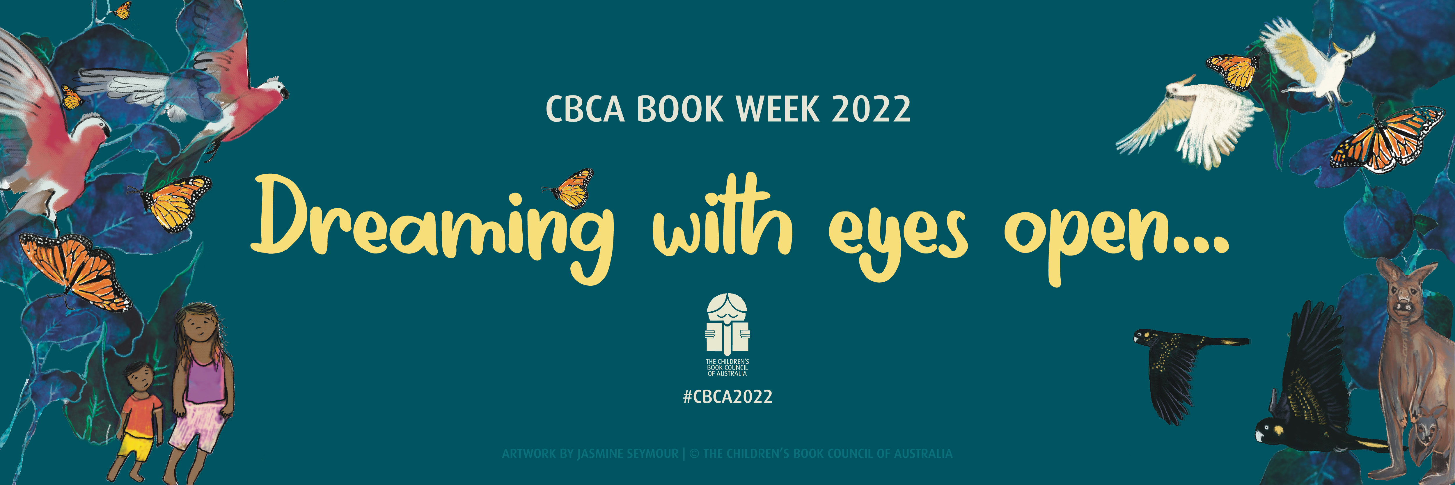

We will be celebrating Book Week this year with a dress-up parade followed by a range of activities based on some of the short-listed books. Dig through the dress-up box to find something fun to wear!

